[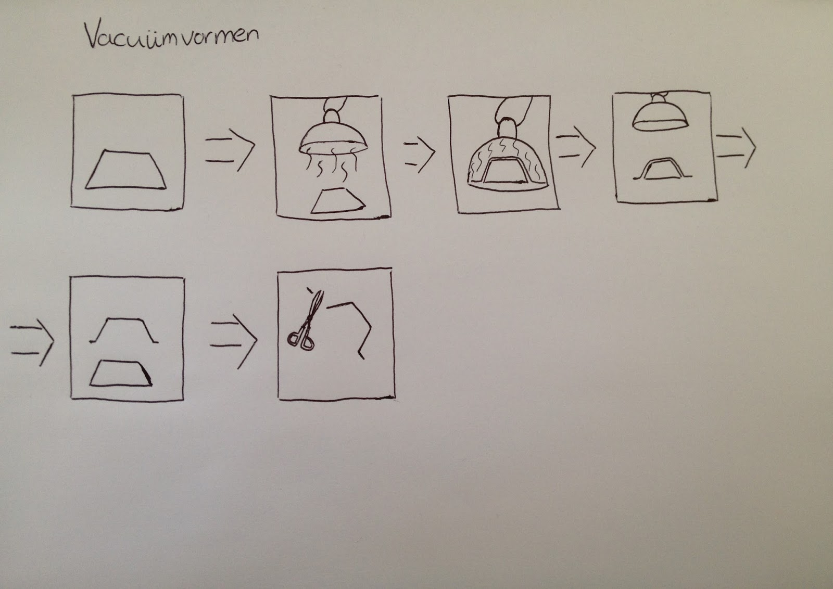](https://www.google.nl/url?sa=i&rct=j&q=&esrc=s&source=images&cd=&cad=rja&uact=8&ved=2ahUKEwiAsaXSquzdAhXOLlAKHaafC6AQjRx6BAgBEAU&url=http%3A%2F%2Flieskesumma.blogspot.com%2F2016%2F10%2F&psig=AOvVaw1PbkcaJ5WLoufK01Ya8ZqE&ust=1538726927804879)[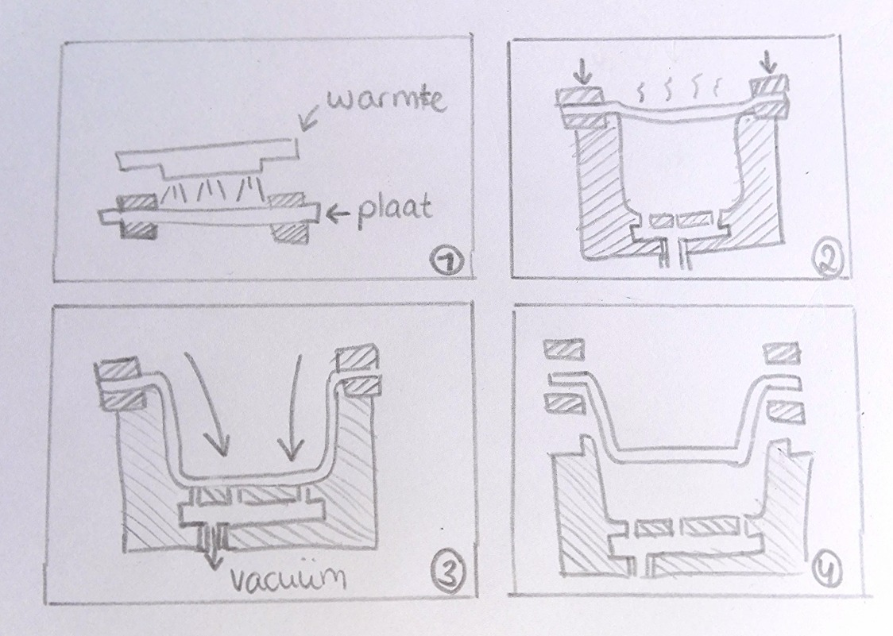](https://www.google.nl/url?sa=i&rct=j&q=&esrc=s&source=images&cd=&cad=rja&uact=8&ved=2ahUKEwiKx_PcquzdAhVLZFAKHdybDo8QjRx6BAgBEAU&url=http%3A%2F%2Firislauwereijs10.wixsite.com%2Fipoblog%2Fsingle-post%2F2016%2F10%2F09%2Fvacu%25C3%25BCmvormen&psig=AOvVaw1PbkcaJ5WLoufK01Ya8ZqE&ust=1538726927804879)