[](https://www.google.com/url?sa=i&rct=j&q=&esrc=s&source=images&cd=&ved=2ahUKEwiDoOn_2YTjAhVJKFAKHfeTBegQjRx6BAgBEAU&url=https%3A%2F%2Fcourius.com%2Fwelke-wereld-geef-je-door-aan-je-kinderen%2F&psig=AOvVaw1Ft2s73nQh3CKwESpsjrN8&ust=1561554507535007)[](https://www.google.com/url?sa=i&rct=j&q=&esrc=s&source=images&cd=&ved=2ahUKEwjJpJfe2YTjAhXKbVAKHYPUA-YQjRx6BAgBEAU&url=https%3A%2F%2Fwww.yoursurprise.nl%2Fboek-met-naam%2Fkinderboeken&psig=AOvVaw1DFhLrCoIKp19EeE105_pc&ust=1561554431232783)[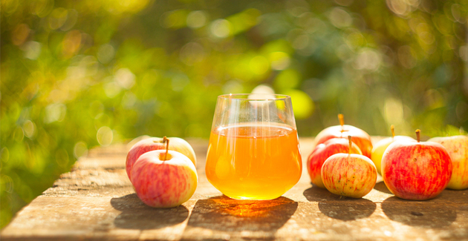](https://www.google.com/url?sa=i&rct=j&q=&esrc=s&source=images&cd=&ved=2ahUKEwiK953O14TjAhUNYVAKHeRSDewQjRx6BAgBEAU&url=https%3A%2F%2Fwww.libelle.nl%2Flekker-in-je-vel%2Fgezondheid%2Fappelsap-helder-gelatine%2F&psig=AOvVaw0YX_3Nyb3qPS3vDezqSGA7&ust=1561553860918662)[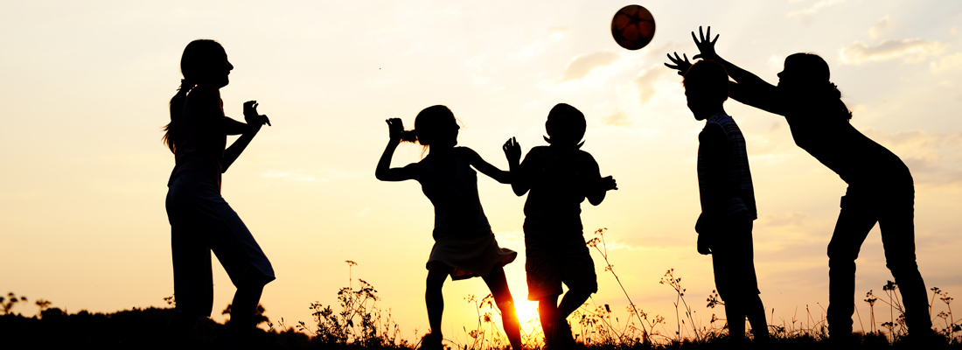](https://www.google.com/url?sa=i&rct=j&q=&esrc=s&source=images&cd=&ved=2ahUKEwjYmMn91oTjAhUQbFAKHRttB7UQjRx6BAgBEAU&url=https%3A%2F%2Fwww.maxvandaag.nl%2Fblogs%2Fbuitenspelen-met-een-prinses%2F&psig=AOvVaw2GuERU6XWyGVfNCNNwLWpq&ust=1561553696139663)**[](https://www.google.com/imgres?imgurl=https%3A%2F%2Findebuurt.nl%2Feindhoven%2Fwp-content%2Fuploads%2F2019%2F06%2Fbuiten-zwemmen-wikimedia_1.jpg&imgrefurl=https%3A%2F%2Findebuurt.nl%2Feindhoven%2Fdoen%2Fhitte-tips-buiten-zwemmen-op-deze-plekken-in-en-nabij-eindhoven~81069%2F&docid=uX1CdMMlue6AwM&tbnid=8d69sj5znNDvzM%3A&vet=10ahUKEwjQ8JGs14TjAhVIaJoKHZfmDikQMwhCKAIwAg..i&w=2048&h=1365&bih=621&biw=1239&q=zwemmen&ved=0ahUKEwjQ8JGs14TjAhVIaJoKHZfmDikQMwhCKAIwAg&iact=mrc&uact=8)**[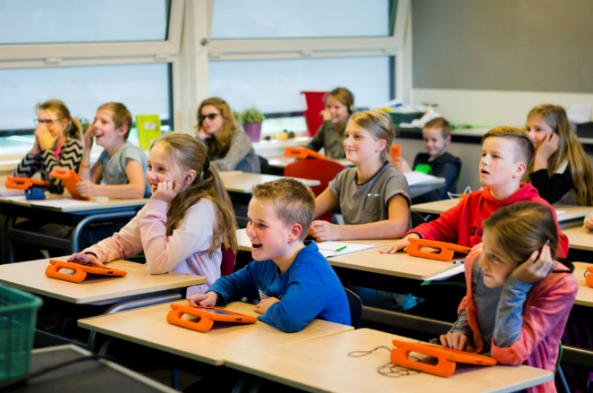](https://www.google.com/url?sa=i&rct=j&q=&esrc=s&source=images&cd=&ved=2ahUKEwjTxqf01oTjAhUCU1AKHYnOBu4QjRx6BAgBEAU&url=https%3A%2F%2Fwww.gbsdespringplank.nl%2Fhome%2Fbasisschool-springplank-leek-dalton-gbs-1%2F&psig=AOvVaw1LY-mjIOV_LndvSZwxrhvu&ust=1561553676643229)**[](https://www.google.com/imgres?imgurl=https%3A%2F%2Fs.s-bol.com%2Fimgbase0%2Fimagebase3%2Flarge%2FFC%2F2%2F0%2F7%2F1%2F9200000081631702.jpg&imgrefurl=https%3A%2F%2Fwww.bol.com%2Fnl%2Fp%2Fsony-playstation-4-slim-console-500-gb-zwart%2F9200000081631702%2F&docid=HrSYOOh349iMIM&tbnid=amxd4j8gI6UqCM%3A&vet=10ahUKEwjD89To1oTjAhWI16YKHbHPAs0QMwhVKAMwAw..i&w=550&h=218&bih=621&biw=1239&q=playstation&ved=0ahUKEwjD89To1oTjAhWI16YKHbHPAs0QMwhVKAMwAw&iact=mrc&uact=8)**[](https://www.google.com/url?sa=i&rct=j&q=&esrc=s&source=images&cd=&ved=2ahUKEwjYx5rC2YTjAhWPb1AKHacRBfsQjRx6BAgBEAU&url=http%3A%2F%2Fwww.inzigd.nl%2Fkinderen%2F&psig=AOvVaw18UehOKnHlvXZ-fGckNUfP&ust=1561554376188977)**[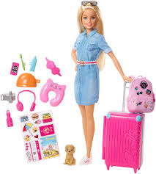](https://www.google.com/imgres?imgurl=https%3A%2F%2Fimages-na.ssl-images-amazon.com%2Fimages%2FI%2F81aohg%252B8SBL._SL1500_.jpg&imgrefurl=https%3A%2F%2Fwww.amazon.com%2FBarbie-FWV25-Travel-Doll%2Fdp%2FB07GLMHSS8&docid=SO1n_C0ieFl7aM&tbnid=cLDzGWgfl599KM%3A&vet=10ahUKEwj0ydWi14TjAhXLxaYKHa4PAy0QMwhxKAAwAA..i&w=1348&h=1500&bih=621&biw=1239&q=barbie&ved=0ahUKEwj0ydWi14TjAhXLxaYKHa4PAy0QMwhxKAAwAA&iact=mrc&uact=8)[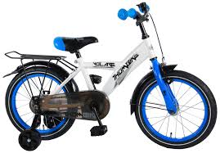](https://www.google.com/imgres?imgurl=https%3A%2F%2Fwww.volare-kinderfietsen.nl%2Fimages%2Fdetailed%2F18%2FVolare_Thombike_16_inch_kinderfiets_tr-W1800.jpg&imgrefurl=https%3A%2F%2Fwww.volare-kinderfietsen.nl%2Fkinderfietsen-jongensfietsen%2F16-inch%2F&docid=Xo4-QsS2teUQnM&tbnid=vb03RTXmFFmqRM%3A&vet=10ahUKEwi-lq6L14TjAhV566YKHcDgA9wQMwj5ASgBMAE..i&w=1800&h=1252&bih=621&biw=1239&q=kinderfiets&ved=0ahUKEwi-lq6L14TjAhV566YKHcDgA9wQMwj5ASgBMAE&iact=mrc&uact=8)[](https://www.google.com/imgres?imgurl=https%3A%2F%2Fwww.horecagoedkoop.nl%2Fmedia%2Fcatalog%2Fproduct%2Fcache%2F207e23213cf636ccdef205098cf3c8a3%2Fc%2Fo%2Fcoca-cola-nl-blik.jpg&imgrefurl=https%3A%2F%2Fwww.horecagoedkoop.nl%2Fcoca-cola-blik-24x33cl&docid=h6AiL8eVPepe8M&tbnid=IzpSS_9G8Ul-fM%3A&vet=10ahUKEwjflsXE14TjAhUixcQBHa47CkIQMwhwKAEwAQ..i&w=700&h=700&bih=621&biw=1239&q=cola&ved=0ahUKEwjflsXE14TjAhUixcQBHa47CkIQMwhwKAEwAQ&iact=mrc&uact=8)**[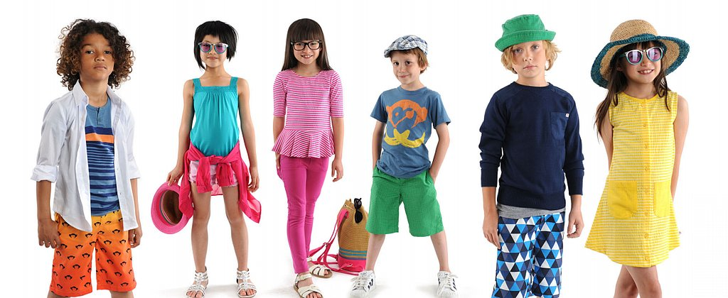](https://www.google.com/url?sa=i&rct=j&q=&esrc=s&source=images&cd=&cad=rja&uact=8&ved=2ahUKEwjTo93w14TjAhWMJVAKHUGsBPEQjRx6BAgBEAU&url=%2Furl%3Fsa%3Di%26rct%3Dj%26q%3D%26esrc%3Ds%26source%3Dimages%26cd%3D%26ved%3D%26url%3Dhttp%253A%252F%252Fwww.peuters.zijnonline.nl%252F%26psig%3DAOvVaw0FiA9MHa_1Qz-9FQ6FDqA2%26ust%3D1561553894310282&psig=AOvVaw0FiA9MHa_1Qz-9FQ6FDqA2&ust=1561553894310282)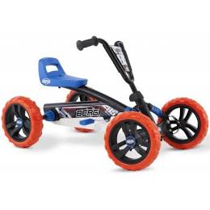**[](https://www.google.com/url?sa=i&rct=j&q=&esrc=s&source=images&cd=&ved=2ahUKEwjNvfru1oTjAhWSLlAKHYefBeEQjRx6BAgBEAU&url=https%3A%2F%2Fwww.cdhal.nl%2Fkinderen-voor-kinderen-39-kom-erbij-cd&psig=AOvVaw02hmnPN2BzycwD7b1Op5Bo&ust=1561553666081324)[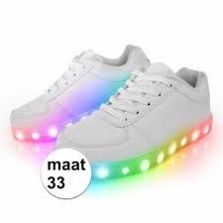](https://www.google.com/imgres?imgurl=https%3A%2F%2Fwww.2kidsonly.nl%2Fimg%2F806%2F1%2Fdisco-led-kinderschoenen-maat-33.jpg&imgrefurl=https%3A%2F%2Fwww.2kidsonly.nl%2Fkinder-schoenen-laarzen%2Fdisco-led-kinderschoenen-maat-33.html&docid=Vw6c2H_NhIkxkM&tbnid=XBKrbtaecvFSEM%3A&vet=10ahUKEwit9emS14TjAhVJK5oKHV4dC8kQMwj_ASgFMAU..i&w=380&h=380&bih=621&biw=1239&q=kinderschoenen&ved=0ahUKEwit9emS14TjAhVJK5oKHV4dC8kQMwj_ASgFMAU&iact=mrc&uact=8)**

**Kinderen van 10**